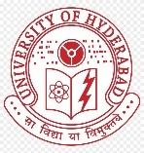 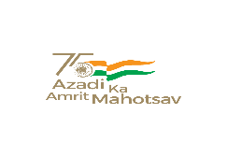 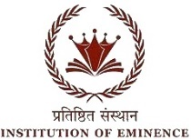

**BHARAT KA AMRIT MAHOTSAV**

UNIVERSITY OF HYDERABAD

SCHOOL OF COMPUTER AND INFORMATION SCIENCE

Collaboration with O/o Dean Student Welfare & O/o Chief Warden

Cordially invites you to Technical Sessions of Two days National Seminar on “BAM-2022“

Organized on 7th & 8th April 2022

Technical Session on “AI methods for speech and Indian language research”

**7th****April 2:00pm to 3:45pm** **Venue:** **New Seminar, SCIS**

|  |  |  |
| --- | --- | --- |
| **Session Chair** | Dr. Ajit Kumar  Soongsil University |  |
| **Rapporteur** | Ms. Srijita Majumdar |  |
| **Keynote speech by** | Dr. N S Reddy  Gyeongsang National University | **2:00 – 2:15** |
| **Student paper presentation** | | |
| **Mr. Nilabja sarkar** | On recent trends in translation and analysis of Sanskrit Vedic texts | **2:15 – 2:30** |
| **Ms. Kashish Gupta** | Understanding transformer-networks for efficient Machine translation of Indian languages | **2:30 – 2:45** |
| **Mr. Anubhab Chakraborty** | On machine translation methods for local Indian languages | **2:45 – 3:00** |
| **Mr. Arkaprava Basu** | Using computer vision approaches for OCR recognition of Devanagari scripts | **3:00 – 3:15** |
| **Mr. Anwar Ali** | A brief study on tools for Automatic Speech recognition for Indian Languages | **3:15 – 3:30** |